Two-Day Hands-on Workshop on IOT Application using Arduino

IEEE MVSR SB Circuits and Systems Society (CASS) in association with ECE Department MVSREC has conducted a Two-Day Hands-on Workshop on IOT Applications using Arduino for the faculty of Electronics and Communication Engineering. The main objective of organizing this workshop was to enhance the faculty’s knowledge and skills in IOT applications using Arduino through hands-on experience.

Session Details:

Date: 1st - 2nd September, 2023

Timings: 09:00 AM – 4:30 PM

No. of Attendees: 35, No. of IEEE members:4 Non-IEE members: 32

Speaker: Dr. M. Shyamsunder

Dr. M. Shyamsunder is an Assistant Professor in the Department of ECE at Osmania University, Hyderabad. He has 18 years of teaching experience, and 3 years of industrial experience and has published over 25 research papers in reputed journals and conferences. He also received the Best Paper Award for the IEEE conference (UPCON) in 2017.

Workshop Poster

Day 1: 01-09-2023
Session-1

Mrs. S. Aruna, Student Chapter Advisor, IEEE MVSR CASS has commenced the session by extending a warm welcome to Dr. M. Shyamsunder, Associate Professor, ECE Department Osmania University, and all the participants. Dr. M. Shyamsunder addressed the gathering and provided an introduction to embedded systems, their applications, and their scope in various industries. It covered open-source platforms, such as Arduino, and also gave an overview of microcontrollers, with a focus on the powerful and widely used AVR microcontroller. Dr. M. Shyamsunder also discussed the differences between microcontrollers and microprocessors, microcontroller architecture, and interfacing, and demonstrated how to use microcontrollers in circuits. This session also covered programming languages, particularly embedded 'C'.

Later, Dr. M. Shyamsunder delivered a comprehensive introduction to the software toolchain, covering topics such as software installation, and getting started with the Arduino IDE and participants gained practical experience by writing their first 'Embedded C' program using the Arduino IDE.

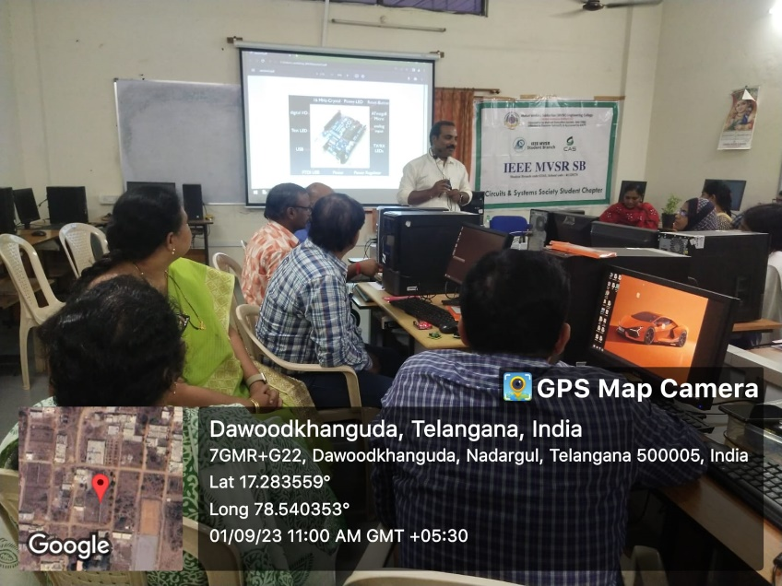
Speaker addressing the gathering in session 1

Session-2

In the second session, the speaker provided an overview of interfacing I/O devices with Arduino. The topics covered included different types of LEDs, their working principles, and how to make them glow in sequence. Dr. M. Shyamsunder also discussed various types of switches, their functions, and how to interface them with Arduino. Additionally, the session covered different types of buzzers, their real-time uses, and how to interface them with Arduino. The speaker also went into detail about the types of display devices, focusing on the seven-segment display, its internal structure, and how to interface it with Arduino. Multiplexing techniques were also discussed.

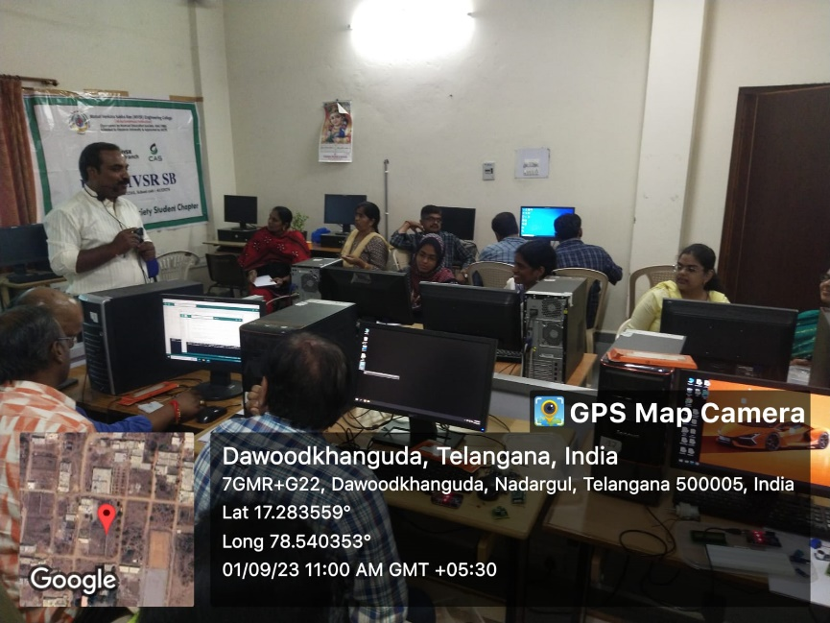
Speaker addressing the gathering in Session 2

Day 2: 02-09-2023
Session-1
Dr. M. Shyamsundar resumed the workshop by introducing the concept of ADC (Analog to Digital Conversion) and its uses. He also gave an overview on resolution, uses of different ADC registers, and interfacing of Analog devices with the digital world. Next, the speaker went on to teach serial communication, and its differences with parallel communication, USART/ UART protocol, RS232 Standard, and TTL converter, and the session was concluded with the topic of UART programming.

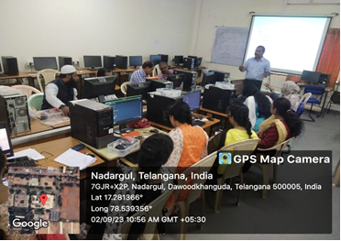
Speaker addressing the gathering in session 1

Session 2

In session two, the speaker gave some hands-on experience to the participants using the Arduino microcontroller. It included some projects like Blinking LED, De-bouncing, counter using 7 segment display, Things to speak app and PC-MC communication. The Things to Speak app was quite interesting and was observed practically. Bluetooth was interfaced with Arduino and verified practically. All the participants got familiarised with the IOT devices and were able to interface various sensors to the Arduino microcontroller with the help of hands-on experience.

Finally, the session was concluded with a vote of thanks by B. Bhavani, Assistant Professor, ECED, MVSR.
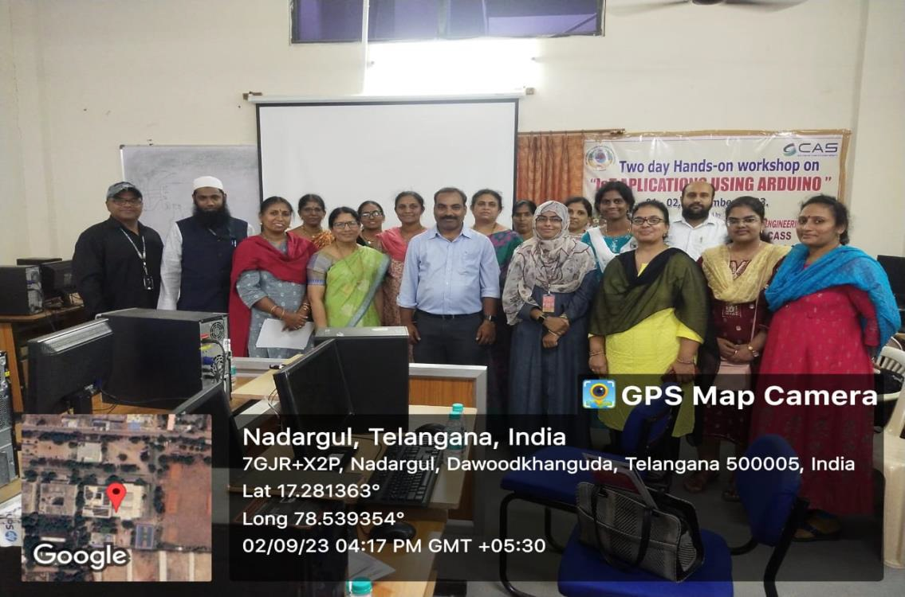
Group photo

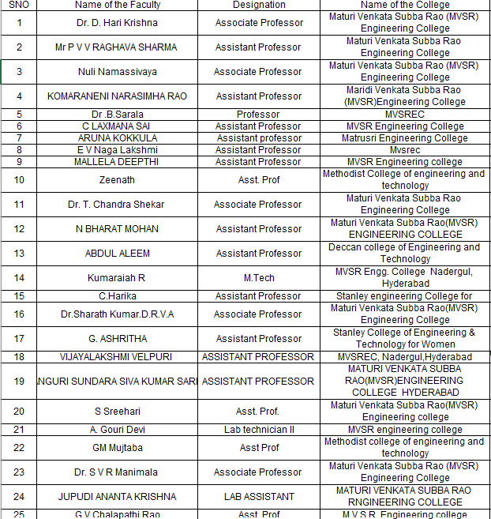
List of Attendees:

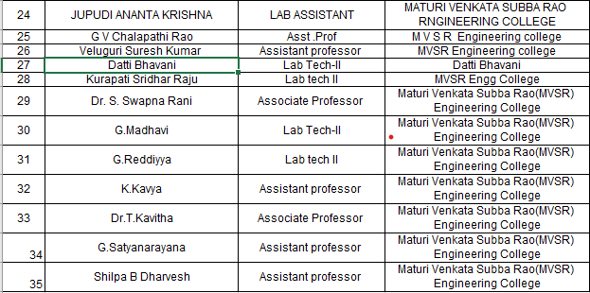

Reported by:
IEEE MVSR SB

